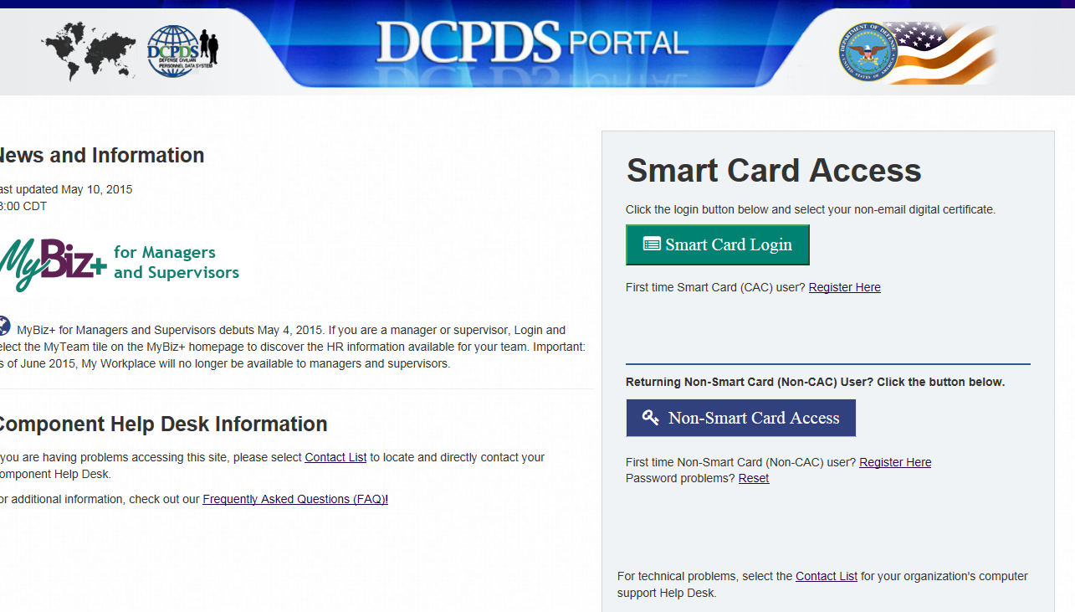

Once in the Navigator screen, all Responsibilities will be listed.  Also all functions will now be under each responsibility.

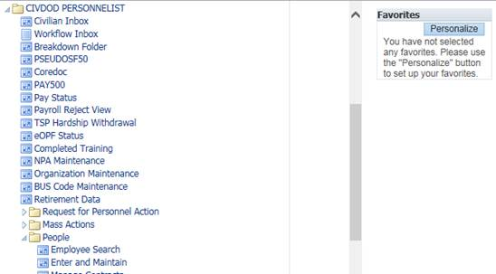

Access the DCPDS Portal via **https://compo.dcpds.cpms.osd.mil/**



Accessing DCPDS Accounts

Access the DCPDS Portal via **https://compo.dcpds.cpms.osd.mil/**



Civilian Personnel Office

987-3212

Access the DCPDS Portal via **https://compo.dcpds.cpms.osd.mil/**



This should be what your screen/access looks like once you complete the prior steps

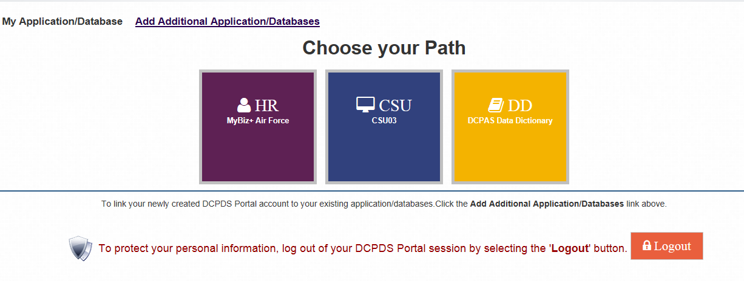

If you click in the purple box it should bring you to the following screen… Click on Accept

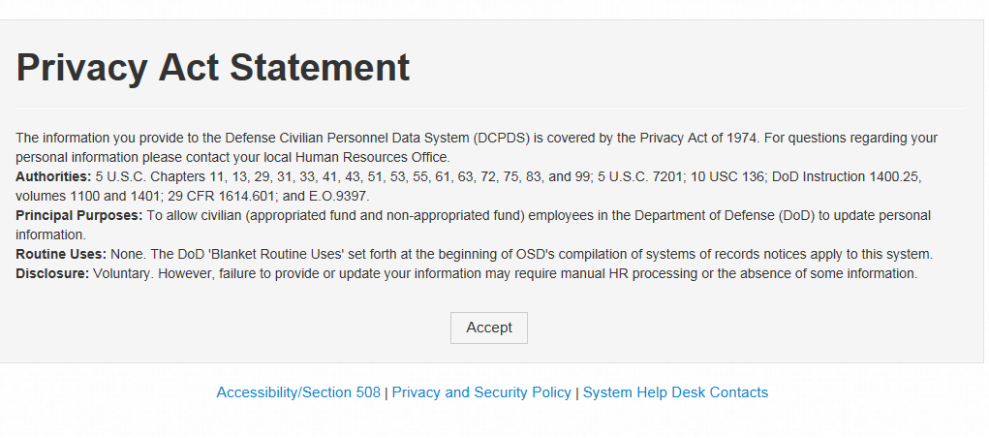

Access the DCPDS Portal via **https://compo.dcpds.cpms.osd.mil/**



Click on

“Add Additional Application/Databases”

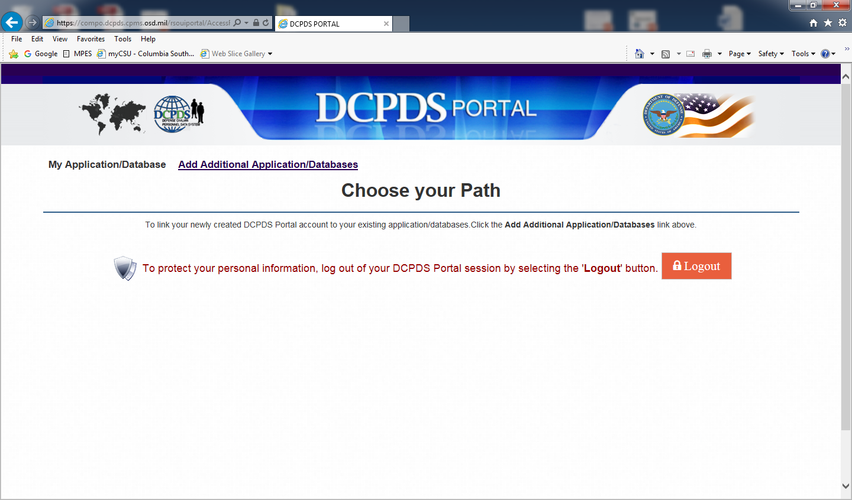

You can now use your social security number to sign in (insert it in the username and again in confirm username)

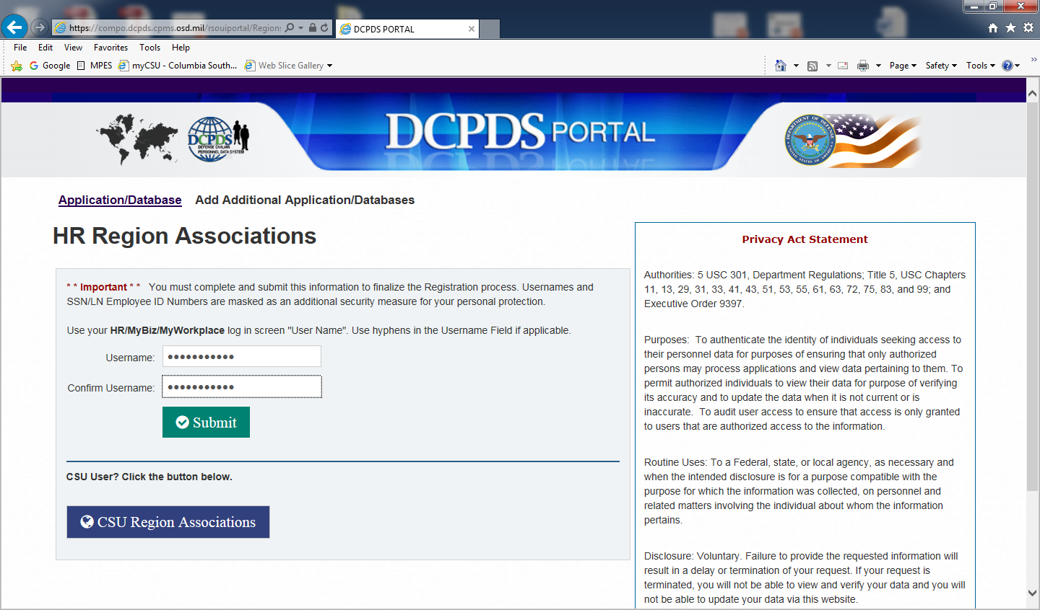

Access the DCPDS Portal via **https://compo.dcpds.cpms.osd.mil/**



Click on First Time Smart Card User



Enter your Social Security number including dashes and click enter

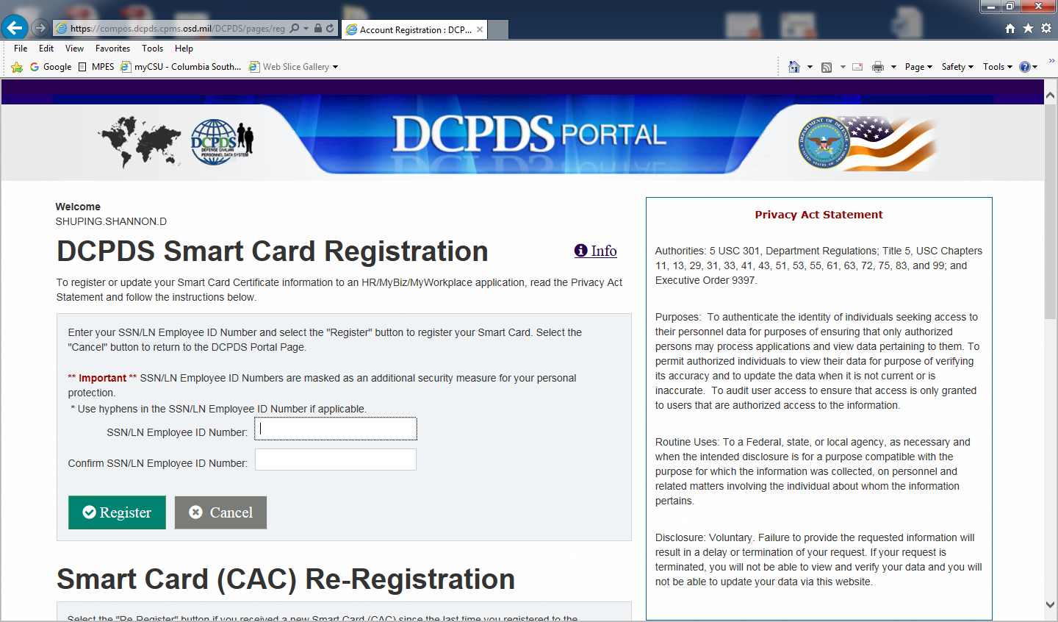

Access the DCPDS Portal via **https://compo.dcpds.cpms.osd.mil/**