Resources For Managers Of Telework Employees

\* TELEWORK.GOV WEB SITE

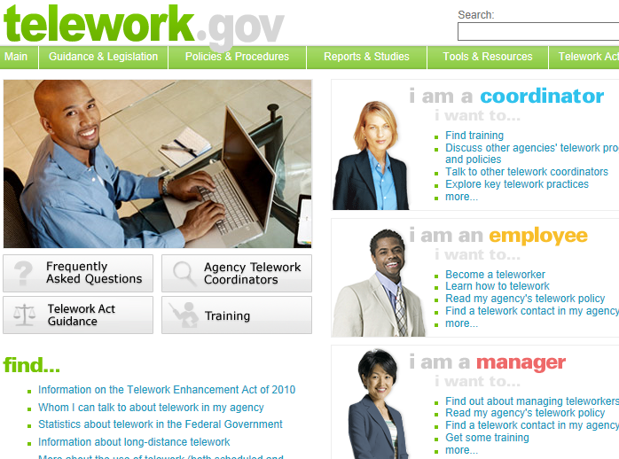

\* AF e-Learning Books 24x7

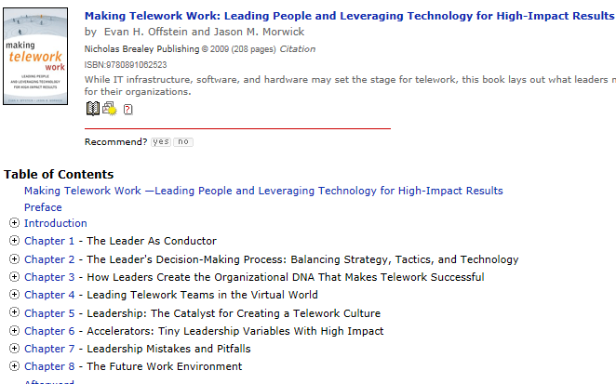

\* AMC EIM SITE

\* AMC CHECKLIST

https://eim.amc.af.mil/org/a1/a1k/A1KK/default.aspx



\* AFI 36-816 CIVILIAN TELEWORK PROGRAM