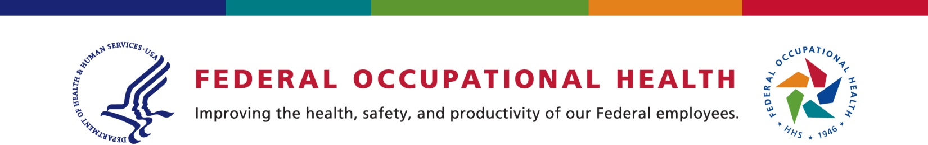

INTRODUCING YOUR
Employee Assistance Program

Today, employees are busy juggling work and family and it is not unusual to encounter difficulties with stress, family, relationships, alcohol, work, or other concerns, which can have an effect on your overall quality of life. To address these concerns, we have partnered with Federal Occupational Health (FOH), to provide you with a wide range of Employee Assistance Program (EAP) services at no cost to you.

With just a phone call or a keystroke, you can access services on the Internet and via a professionally staffed call center.

EAP services are convenient and confidential. Licensed counselors are available to help with difficult personal issues. These are just some of the services that are available to you:

- Access to licensed counselors who provide in-person, short-term counseling
- Assistance with a wide range of concerns – relationships, legal, financial, family, substance abuse, children, and more
- Crisis Management
- Supervisor and Management Coaching
- Information and Resources from a Robust Website - FOH4You.com
- Child and Elder Care Resources
- On-Line Presentations, Webinars, and Podcasts

Telephone Access
To make a confidential EAP appointment with a licensed counselor call 1-800-222-0364 (or 888-262-7848 if you are hearing-impaired). Call anytime – we’re available 24/7. You will be offered assistance or given an appointment to meet with a counselor. Meetings with your counselor are confidential within the guidelines of the law.

When contacting the EAP please use Headquarters Air Mobility Command (AMC) to identify your agency.

Online Access
Go to www.FOH4You.com (click “enter”) to access information and resources, self-help assessments, webinars, podcasts, and more.

To access on-line presentations go to Quick Links and choose the presentation you want to view. Select option “watch video” (for some presentations) and select your agency from the pull down menu.

To access legal and financial information go to Benefits and select Legal and Financial Consultation.
Employee Assistance Program
(800) 222-0364 | (888) 262-7848 (TTY)
www.FOH4YOU.com

